蒋雅先老师四节微课截图

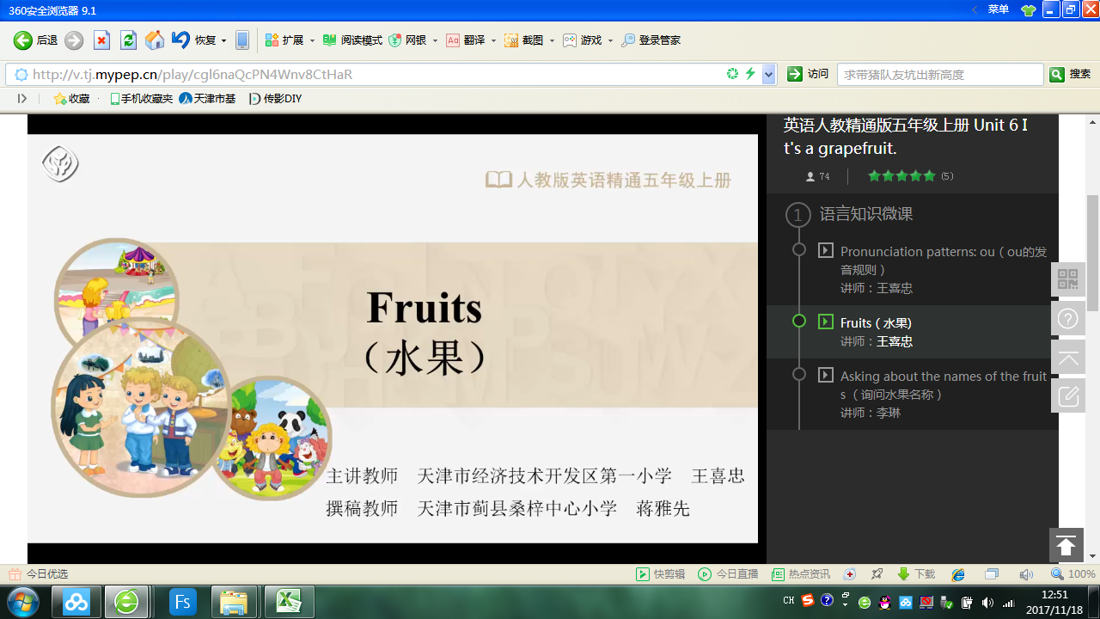

http://v.mypep.cn/play/cgl6naQcPN4Wnv8CtHaR

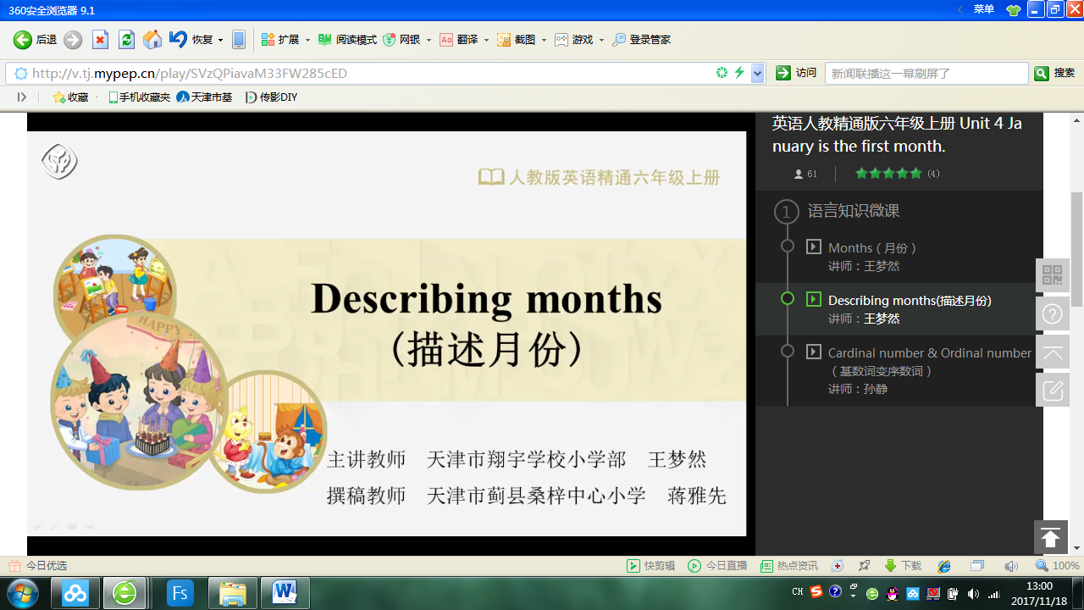

英语人教精通版六年级上  
http://v.mypep.cn/play/SVzQPiavaM33FW285cED

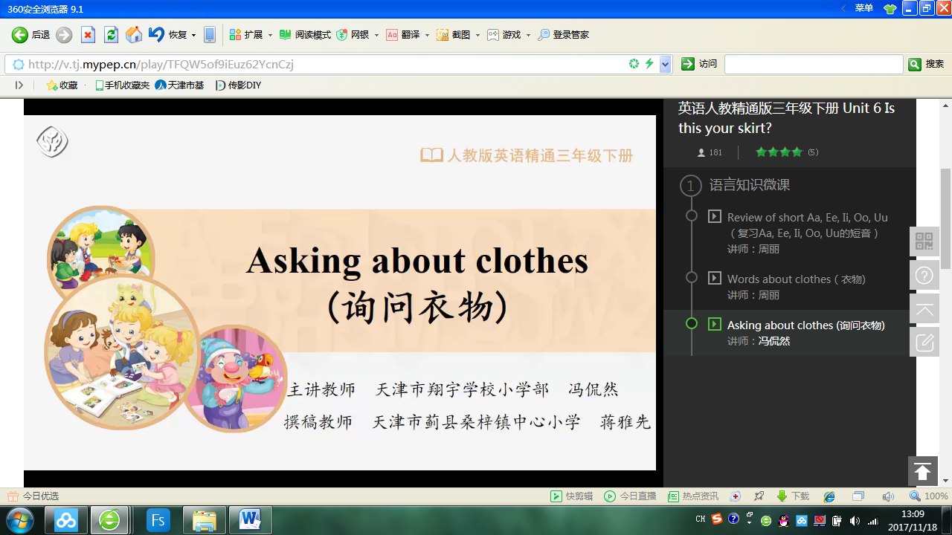

http://v.mypep.cn/play/cgl6naQcPN4Wnv8CtHaR

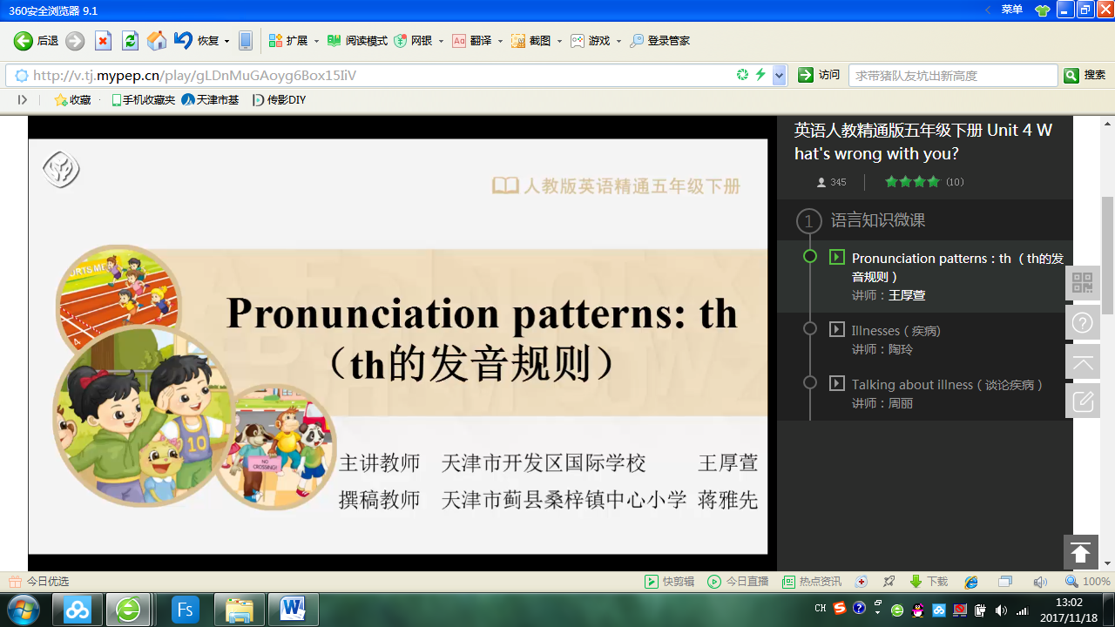

http://v.mypep.cn/play/gLDnMuGAoyg6Box15IiV