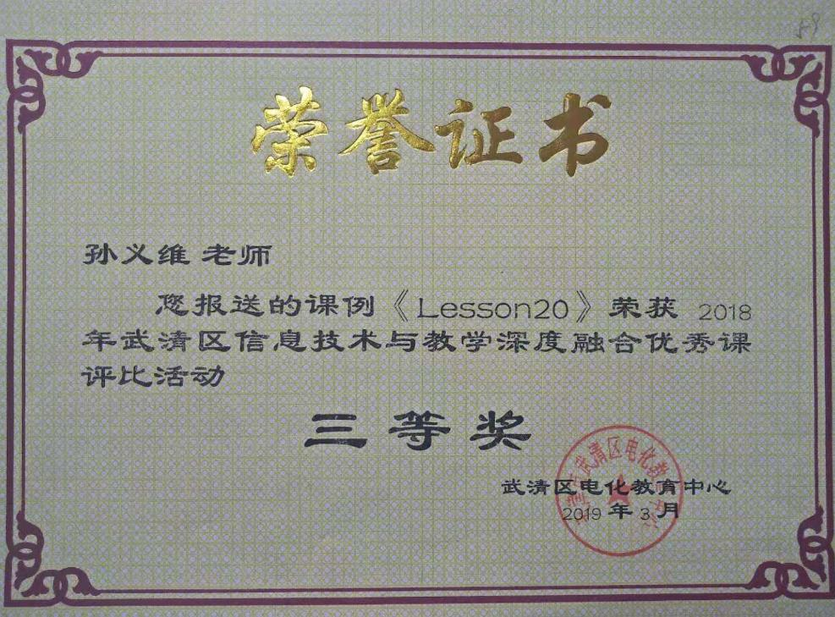
五年级下册《Lesson 20》教学案例
一、目标：
1.知识与能力目标：
Guide the students to grape the four skills material in different ways while try to use them into the real language situation.
2.过程与方法目标：
Learn some phrases about sick and how to express the illness.
3.情感态度与价值观目标：
Cultivate the students to keep good healthy.
二、重难点：
I’m ill today. I have a bad cold.
have a fever have a cough have a headache
通过学习新知识，用所掌握的语言知识完成任务。
三、准备材料（教具、学具、资料等）：
The tape-recorder pictures cards
四、教学环节
Step1: Warm-up
1. Is everyone here? Who? Gaowei can’t have English lessons with us. It’s a pity. Let’s listen.
S: Is that Mr Sun?
T: Yes.
S: Good moring, Mr Sun. This is Gaowei. I’m afraid I can’ t go to school today.
2. Gaowei can’t come to school today .Why? Can you guess?
设计意图：用微信的方式导入本课，设疑高伟为什么没来上学，激发学生的好奇心，让学生自然的进入本课的情境中，创造学习英语的氛围。

Let’s look
T: What’s wrong with you?
S: I’m ill today. I have a headache.
T: Oh, dear! Do you have a cold?
S: Yes, I have a bad cold.
设计意图：通过让学生看微信内容，让学生知道高伟没来上学的原因，并了解如何用英语向老师请假，巩固旧知，为本课的学习奠定基础。
3. Work in pairs and act out it.
设计意图：通过让学生操练、表演，进一步理解所学语言，并应用到实际生活中，提高他们的口语表达能力，为进一步学习新知做了铺垫。
Step2: Presentation
1. Study the new phrase and the new sentences: have a fever
Don’t worry about your lessons. I’ ll help you with your …
T: What’s wrong with you?
S: I’m ill today. I have a fever.
T: Oh, dear! Do you have a cold?
S: Yes, I have a bad cold.
T: Don’t worry about your lessons. I’ ll help you with your …
设计意图：教师适时引出新知，并把新知放入语境中，让学生在所学语言的基础之上，适当增加，达到循序渐进的效果。
2. Work in pairs and act out it.
3. Study the new phrase: have a cough
T: What’s wrong with you?
S: I’m ill today. I have a cough.
T: Oh, dear! Do you have a cold?
S: Yes, I have a bad cold.
T: Don’t worry about your lessons. I’ll help you with your …. You should go to a doctor.
S: OK.
T: Take good care of yourself.
S: Thank you.
设计意图：教师在小助手的帮助下，让新知自然生成，并在学生表演对话的同时，适时生成新的对话内容，降低了学习的难度，树立了学生的自信心，提高了学生的口语表达能力。
4. Work in pairs and act out it.
设计意图：通过让学生操练、表演，进一步理解所学语言，并应用到实际生活中。
Step3: Practice
1. Listen and write.
设计意图：在半真实的语境中，提高学生的听写能力，以及对对话内容的理解。
2. Read quickly.
3. Read in roles.
Step4: Language use
- Invite your friends.

A: Hello! Is that ?
B: Yes, it’s speaking.
A: This is . Can you with me?
B: Sorry, I . I have .
设计意图：在语言构架的基础之上，开发学生的思维，训练学生的口语表达能力。
2. Make up the new dialogues.


A: Hello! Is that ?
B: Yes, it’s speaking.
A: This is . Can you with me?
B: Sorry, I . I have .
A: Oh dear! You should go to a doctor.
B: OK.
A: Have a good rest. Take good care of yourself.
B: Thank you.
A: Good bye.
B: Bye.
设计意图：开发学生的开放性思维，以学生比较喜欢的事情为话题，训练学生的观察、思考以及合理运用语言的能力。
3. Let’s chant.
Step5: Homework
1. Make up a new dialogue.
2. Invite your friends to do something you like.

Writing on blackboard

Lesson 20

I’m ill today.
have a bad cold 图片
have a headache 图片
have a fever 图片
have a cough 图片

